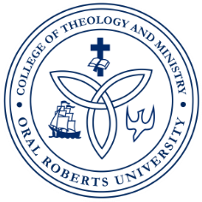
ORAL ROBERTS UNIVERSITY
Graduate School of Theology and Ministry
Master of Arts in Christian Counseling
LPC/LMFT Practicum and Internship Program

Weekly Experience and Evaluation Log

Student Name: ________________________Week of: _________ Site: __________________

Briefly describe Practicum/Internship activities engaged in (individual, family, group counseling, assessments, treatment planning, record keeping, training, audio/video recording, individual/triadic/ group supervision etc.)
_____________________________________________________________________________________
Monday:

Hours completed: ___________
_____________________________________________________________________________________
Tuesday:

Hours completed: ___________
_____________________________________________________________________________________
Wednesday

Hours completed: ___________
_____________________________________________________________________________________
Thursday

Hours completed: ___________
_____________________________________________________________________________________
Friday

Hours completed: ___________
_____________________________________________________________________________________
Saturday

Hours completed: ___________
_____________________________________________________________________________________

Direct Service Hours with Clients: ______________Total hours completed for week: __________

Site Supervisors Weekly Evaluation:
_______________________________________________________________________________________________________________________________________________________________________________________________________________________________________________________________
___________________________________________________ __________________
Student Signature Date
___________________________________________________ __________________
Site Supervisor Signature Date

