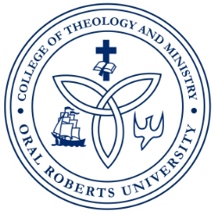
ORAL ROBERTS UNIVERSITY
Graduate School of Theology and Ministry
Master of Arts in Christian Counseling
LPC/LMFT Practicum and Internship Program

RECORD OF SUPERVISED EXPERIENCE

Student Name (print): _________________________________________________________________

Site Supervisor Name (print): __________________________________________________________

Semester/Year __________________Practicum _______Internship I _______Internship 2 _________

Week  Beginning Date | Date(s) Met with Supervisor | Total Number of  Face-to-Face  Supervision Hours  (GRP) (TRI) (IND) | Total Number of Direct Client Contact Hours | Total Number of Supervised Experience Hours
1
2
3
4
5
6
7
8
9
10
11
12
13
14
15
Total Hours

Student Intern Signature: _______________________________________ Date: __________________

Site Supervisor Signature: _______________________________________ Date: __________________

